Geotechnical Engineering Considerations for Extraterrestrial Infrastructure Construction

James K. Mitchell¹, Sc.D., P.E., Dist. M. ASCE and W. David Carrier III², Sc.D., P.E., Fellow, Life M. ASCE

¹University Distinguished Professor Emeritus, Virginia Tech, Blacksburg, VA 24061-0105; jkm@vt.edu
²Director, Lunar Geotechnical Institute, Lakeland, FL 33807-5056; wdcarrier@verizon.net

ABSTRACT: It is only a matter of time until space exploration enters a new phase that will include additional manned and unmanned landings and explorations on the Moon, Mars, and perhaps on asteroids. Detailed knowledge of the soils and rocks will be needed for the design of foundations for structures, for excavation and underground space utilization, for design of surface vehicles and construction of transportation systems, for evaluation of their suitability as construction materials and development of construction methods. In-situ resource utilization can be expected to play a major role in these activities owing to the high cost and difficulty in transporting needed materials from Earth. The extreme environments in which the work is to be carried out will complicate virtually every activity to be undertaken.
Current knowledge about the rocks and soils on the Moon and Mars is summarized, with particular emphases on their compositions, geotechnical properties and in-situ states. Some implications for geotechnical engineering and foundation design are stated. Were it not for the unique and harsh environmental conditions, in addition to the great distance from Earth and its impacts on material transport and communications, engineering and construction on, in, and with the silty fine sandy soils of the Moon and Mars would be straightforward.

Keywords: dust, extra-terrestrial soils, geotechnical engineering, infrastructure, lunar soil mechanics, Mars, Moon, soil composition, soil properties, space exploration

INTRODUCTION

The surface is fine and powdery. I can pick it up loosely with my toe. It does adhere in fine layers like powdered charcoal to the sole and insides of my boots.

423

I only go in a small fraction of an inch – maybe an eighth of an inch – but I can see the footprints of my boots and the treads in the fine sandy particles.

These words by Neil A. Armstrong on July 20, 1969, immediately following his first step onto the Moon and his memorable statement: Thats one small step for (a) man; one giant leap for mankind, marked the beginning of a new era in geotechnical engineering. Now, forty years later, after a significant hiatus in manned space exploration, planning is well underway for a new generation of missions leading to further exploration of the moon and near solar system. NASAs Constellation Program calls for a return to the Moon by 2020 and then on to Mars sometime after 2030.
As with all high cost, high risk ventures such as this, many ask WHY? Some of the answers with respect to the Moon are the following:
- To pursue scientific questions about the origin and history of the Earth, solar system, and universe
- To test space technologies, systems, flight operations
- To obtain experience in extraterrestrial living
- To develop strategic (military) advantages
- To establish an observatory
- To provide a platform for Earth monitoring
- To establish a jumping off place for further space exploration
Similar reasons apply with respect to Mars and inevitably to other planets and asteroids. For some, sufficient justification is simply that (1) the Moon and Mars are there, and (2) we humans want to know, and when we no longer want to know, we are no longer human.
No matter what the activity to be done on the Moon, Mars, or other extraterrestrial bodies, it will be done on, in, or with the soils that are there. The purposes of this paper are to summarize current knowledge and understanding of the types and geotechnical properties of the soils on the Moon and Mars, and to identify some important considerations in geotechnical engineering for safe operations and facility design and construction in the unique and harsh environmental conditions encountered there.
This paper has been prepared for inclusion in the ASCE Geo Institute Geotechnical Special Publication honoring our distinguished colleague, Clyde N. Baker, Jr. and his many monumental contributions to foundation engineering, especially deep foundations for most of the worlds tallest structures. Although similar structures are not likely soon for the faraway sites and alien conditions considered herein, building the needed infrastructure to support activities on the Moon and Mars will require geotechnical engineering of the highest quality done by imaginative engineers, such as Clyde Baker.

PHYSICAL CHARACTERISTICS AND ENVIRONMENTS OF THE EARTH, MOON, AND MARS

Several physical and environmental characteristics and properties of the Earth, Moon, and Mars are listed in Table 1. The most important of these as they affect the geotechnical properties and mechanical behavior of soils on these three bodies are gravity, temperature, and atmospheric composition and pressure.
Weights and body forces are in proportion to the gravitational field; i.e., 1 to 6 in the case of the Moon to the Earth, and about 1 to 2.64 in the case of Mars to the Earth. Materials such as granular soil that derive much of their strength from friction are correspondingly weaker on the Moon and Mars than on Earth. However, the forces that they will be called upon to carry under static loading are also proportionately less for support of bodies of the same mass. As cohesive forces are independent of gravity, a soil possessing some given amount of cohesion will be disproportionately stronger on the Moon and Mars than on the Earth. These gravitational differences also mean that dynamic forces developed by a given moving mass; e.g. accelerating vehicle, active astronaut, impacting hammer, will be the same for given motions on the Earth, the Moon, and Mars. In effect, the dynamic forces will be significantly greater relative to gravity (body) forces on the Moon and Mars than on Earth.

TABLE 1. Physical Comparison of the Earth, Moon and Mars

Property | Earthª | Moonª | Mars^{b}
Mass | 5.98x10²⁴ kg | 7.35x10²² kg | 0.64x10²⁴ kg
Radius (Spherical) | 6371 km | 1738 km | 3390 km
Surface area | 510.1x10⁶ km² | 37.9 x 10⁶ km² | 144.5x10⁶ km²
Mean density^{c} | 5.52 g/cm³ | 3.34 g/cm³ | 3.93 g/cm²
Gravity at equator | 9.81 m/sec² | 1.62 m/sec² | 3.71 m/sec²
Sidereal rotation | 23.934 hr | 27.32 days | 24.62 hr
time
Orbit period | 365.24 days^{b} | 27.32 days | 686.97 days
Mean surface  temperature Surface | 22°C  -89°C to 58°C | 107°C day  -153°C night^{d}  -233°Ce to 123°C | -63°C  -89°C to -31°C
temperature |  |  | (Viking 1 site)
extremes
Atmosphere | 1013.2 mb surface | 0 mb | from 4.0 to 8.7 mb

pressure
Heat flow 63 mW/m² ~29mW/m² ªValues from Heiken, et al (1991), Table 3.1; ^{b}Values from
surface pressure

http://nssdc.gsfc.nasa.gov/planetary/factsheet/marsfact.html, accessed 12 Jun09; ^{c}This is the mean density of the entire body. Differences among the surficial rock and soil densities are less.; ^{d}Below a depth of 1 m in the Apollo equatorial regions the temperature is approximately constant at -20ºC. ^{e}In permanently shadowed craters in the polar regions.

Both the mean surface temperatures and the temperature extremes differ significantly among the Earth, the Moon, and Mars, as indicated in Table 1. The very high and very low temperatures encountered on the Moon and Mars impact both material behavior and the ease of working. To date no liquid water or ice has been discovered on the Moon, so water interactions with the soil and phase changes are not problems in the regions that have been explored so far¹. Although its geology indicates that liquid water did exist on Mars in the past, evidence of its presence today, except as a polar ice cap in the northern hemisphere, has not yet been obtained. The possibility that there is groundwater is still being studied.
The near absence of any atmosphere (a nearly hard vacuum) on the Moon precludes significant gas adsorption on lunar soil and rock particles, whereas the abundance of oxygen and nitrogen surrounding the Earth provides opportunities for surface reactions that can contribute to both weathering and alterations in physical properties. Although the Martian atmosphere is very sparse compared with that of the Earth; i.e., a surface pressure of 4.0 to 8.7 mb on Mars compared to 1013.25 mb on Earth, the Martian winds are capable of surface erosion and small particle transport. The atmosphere on Mars contains about 95.7 percent CO₂, 2.7 percent Nitrogen, 1.6 percent Argon and 0.2 percent Oxygen.

THE NATURE AND GEOTECHNICAL PROPERTIES OF THE SOILS ON THE MOON AND MARS

Moon

Lunar Rock and Soil Types and Composition

Consolidated rocks of the Moon fall into three categories (Taylor, et al. 1991):
- Basaltic volcanic rocks that include lava flows and pyroclastic (volcanic ash) rocks
- Pristine rocks from the lunar highlands that have original compositions uncontaminated by impact mixing
- Complex polymict breccias formed by impacts that shatter, mix, and recompact the lunar surface and impact melts formed by melting of older rocks during meteoroid impacts.
All of these rocks were originally igneous rocks formed by cooling of molten material (Taylor, et al., 1991). The rocks are composed primarily of pyroxenes, olivine, plagioclase feldspar, ilmenite, and silica minerals in the form of tridymite or cristobalite. Whereas nearly 4000 minerals have been identified in the rocks and soil on Earth, less than 100 have been found on the Moon. This is primarily the result of the absence of atmosphere and water, which are necessary conditions for chemical weathering processes.

¹ The Indian lunar satellite, Chandrayaan-1, may have detected ice just as this paper was going to press. In addition, one of the mission objectives of the U.S. Lunar Reconnaissance Orbiter and the Lunar Crater Observation and Sensing Satellite (which were launched on the same rocket on June 18, 2009) is to determine if ice is present in the polar regions of the Moon.

Soil, also referred to as the regolith, covers virtually the Moons entire surface to a depth of at least 2 m up to as much as 20 m or more (Carrier and Mitchell, 1989). Meteorite impact, at velocities greater than 20 km/s, which breaks big rocks into small rocks, is the dominant soil forming process. Furthermore, the energy of impact melts small particles back into larger particles. In addition, the meteorites strike the Moon isotropically, and thus the soil-forming process is ubiquitous on the lunar surface. This process is estimated to reach steady state after about 100 million years and the result is the rather narrow range of soil particle sizes shown in Fig. 1. Individual soil particles consist of rock fragments, mineral grains, bits of glass, and agglutinates, which are composed of all the other particle types stuck together. Some examples of soil particles are shown in Fig. 2. The gradational characteristics show the soil to be broadly-graded silty fine sand to sandy silt, (SM) or (ML) in the Unified Soil Classification System. Owing to the irregular particle shapes, with reentrant surfaces and enclosed voids in the agglutinates (Carrier and Mitchell, 1989), both the specific surface area and particle crushability are higher than for terrestrial materials of comparable gradation but composed mainly of quartz.
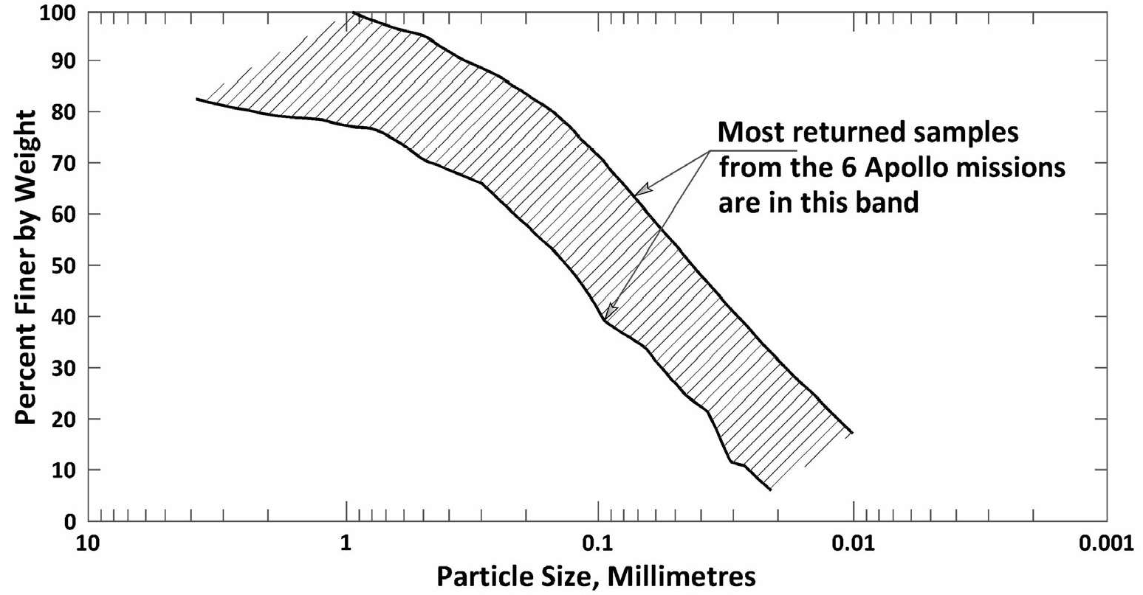

FIG. 1. Particle size distributions of lunar soil samples (redrawn from Carrier, 1973, Mitchell, et al., 1974, and Carrier, 2003)
Lunar Soil Mechanical Properties

Given its gradation, the limited number of minerals, and the absence of water and air (or other gases), lunar soil has engineering properties that depend primarily on relative density. The relative density is 0 to 30 percent (very loose to loose) at the surface, increasing to more than 65 percent (medium to dense) at a depth of 5 cm, greater than 80 percent (dense) at 10 cm depth, and more than 90 percent (very dense) below 30 cm (Carrier and Mitchell, 1989). The bulk density ranges from about 1.3 g/cm³ to slightly greater than 1.8 g/cm³ over this range. The average relative density in the upper 60 cm is 83±3 percent (Mitchell, et al., 1974; Houston, et al., 1974). This density profile is attributed to meteorite impacts that stir and loosen the uppermost few cm but shake and densify the material below (Carrier, et al., 1973).

Overall, the average properties of the lunar soil are quite similar everywhere on the Moon, with less regional variability in average property values than there is locally. Soils on slopes are less dense and weaker than on the flat areas. The range of properties on the Moon is much less than on Earth owing to the absence of water, clay and organics.

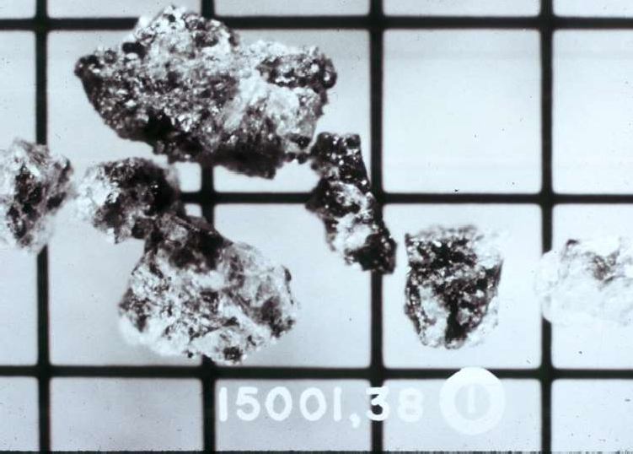
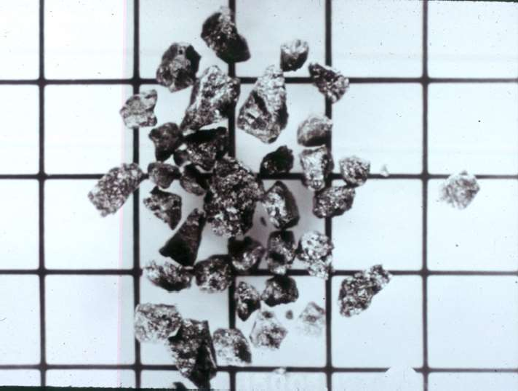
Basalt Fragments Recrystallized Breccia
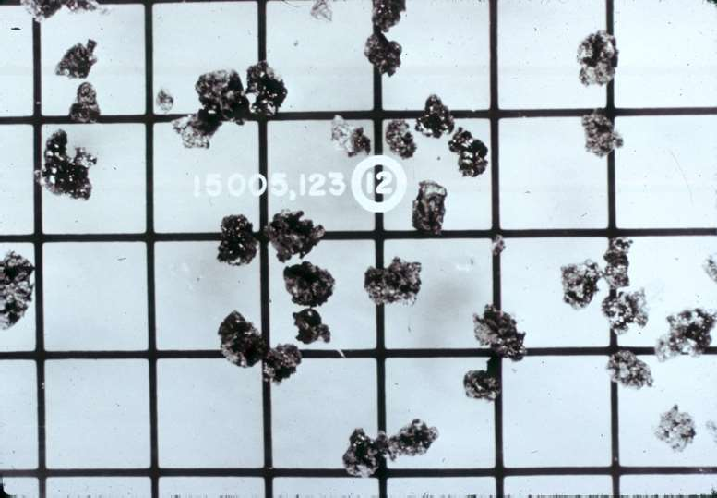
Mineral Grains Agglutinates

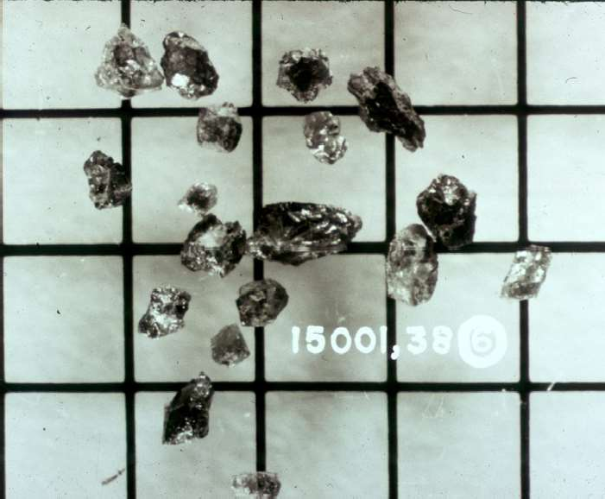
FIG. 2. Some different types of lunar soil particles (Grid spacing is 1 mm.)

The compressibility and strength of lunar soil depend on its state, most notably the relative density, and confining pressure. Compressibility parameters of a remolded lunar soil sample were evaluated by Carrier (1991) and are summarized in Table 2.
Shear strength estimates have been made based on analyses of photographs, remote sensing information, analyses of lunar slope stability, study of boulder tracks on lunar slopes, tests on lunar soil simulants, and study of various interactions with the lunar surface during the Apollo missions. These included landing of the Lunar Module, astronaut bootprints, penetration of different devices into the surface, analyses of open bore holes, and lunar surface penetrometers. The Soviet Lunokhod unmanned rover contained a combined cone penetrometer and vane shear device that could measure strengths to a depth of about 10 cm. Some strength testing of samples returned to Earth by the Apollo missions was also done. Results from these tests have been expressed in terms of a friction angle and cohesion. Ranges of Mohr-Coulomb failure envelopes developed by Carrier (1991) are shown in Fig. 3.

TABLE 2. Compressibility Parameters for Remolded Lunar Soil

Parameter Value

Compression Index, C_{c}
Loose 0.3
Dense 0.05
Recompression Index, C_{r} 0.003
Maximum Past Pressure Unknown

Coefficient of Lateral Pressure, K_{o} (estimated) Normally Consolidated
Overconsolidated
0.45
Unknown

Recompacted 0.7

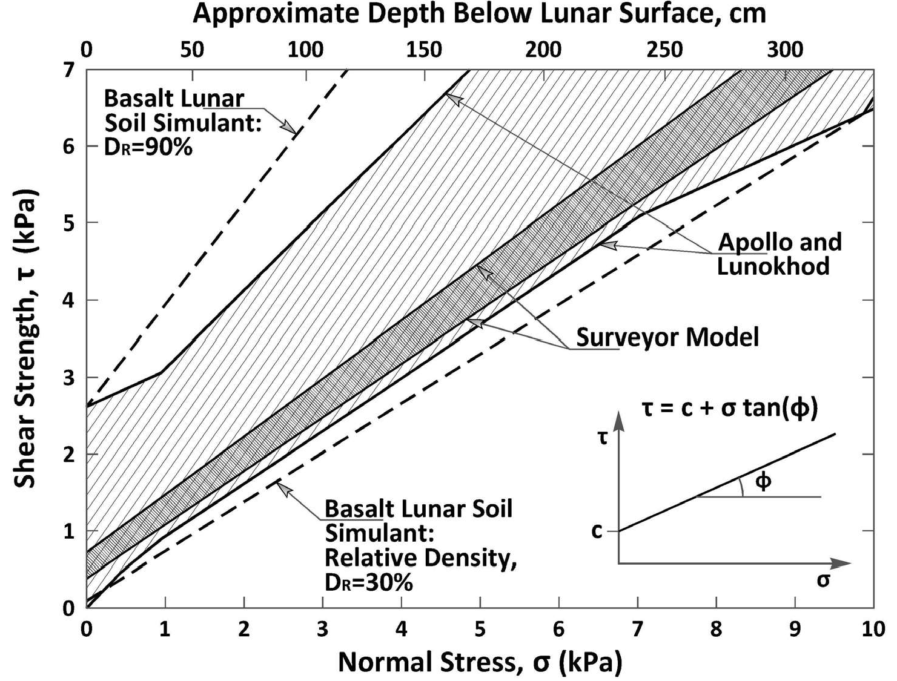

FIG. 3. Lunar soil Mohr-Coulomb failure envelopes (revised and redrawn from Carrier, 1991)
Average shear strength parameters applicable to different depth ranges beneath the lunar surface are given in Table 3 derived from Fig. 9.35 in Carrier (1991). The high friction angles relative to typical values for terrestrial silty fine sands can be explained by the very low confining pressures at shallow depths on the Moon and the irregular particle shapes. The large increase in friction angle with increasing depth range is a consequence of the rapid increase in relative density with depth.

During the Apollo missions, surface activities by the astronauts and wheeled vehicle movements kicked up large quantities of dust that adhered strongly to any surface with which it came into contact. This adhesion is due to electrostatics, the same as is the case for other fine, dusty materials. (The lunar soil also contains elemental iron and thus is magnetic.) In addition, lunar soil appears to have a true cohesion, even at zero confining stress, which is due to tight packing and mechanical interlocking of the irregular particles.
The more fragile particles in lunar soil (agglutinates, breccias, and glasses) tend to crush at confining stresses typically used in terrestrial laboratory testing. This results in a curved failure envelope, such that as the apparent friction angle decreases, the apparent cohesion increases. However, stresses on the Moon are less owing to the low gravity, and the envelopes shown in Fig. 3 are linear. The combination of the two shear strength components still produces a relatively strong material, especially at high in situ relative density.

TABLE 3. Shear Strength Parameters for Different Depth Ranges on the Moon

Depth Range | Friction Angle, | Cohesion, c
(cm) | (Degrees) | (kPa)
0-15 | 41-43 | 0.4-0.6
0-30 | 45-47 | 0.7-1.1
0-60 | 48-51 | 1.3-1.9
30-60 52-55 2.3-3.8

Mars

Whereas the soils on the Moon have been photographed, sampled at several locations, and tested both in-situ and on Earth, less is known about the rock and soil conditions on Mars. What is known has been deduced from remote sensing observations and from several Martian landers and rovers, including Viking 1 and Viking 2 (August and September 1975), Pathfinders rover Sojourner (July 1997), Spirit and Opportunity rovers (January 2004), and the Phoenix Mars Lander (May 2008). Some of what has been learned so far about the rock and soil conditions is summarized briefly below.

Martian Rock and Soil Types and Composition

Six geologic processes have shaped the Martian surface and the materials that are encountered there. These are: (1) tectonic, (2) volcanic, (3) cratering from meteor impact, (4) hydro; i.e., drainage systems, floods, polar ice caps, (5) mass movements; e.g., landslides and debris flows, and (6) aeolian; i.e., wind erosion and dust transport. As noted by Schmitt (2009), the surface is not covered by impact-generated material as on the Moon, and the regolith on Mars is much more complex than that of the Moon. The dominant migrating material is windblown dust coming from a variety of sources such as rocks eroded by wind, landslides, impacts and chemical reactions.

Nonetheless, impact-related geology still dominates the surface and near-surface fabric of most exposed Martian rock formations (Schmitt, 2009).
The thickness of the unconsolidated soil layer and depth to bedrock are not reliably known from the evidence so far obtained. The soil contains silicon, iron, aluminum, magnesium, calcium, titanium, sulfur, and chlorine, but no organic matter has so far been found (Banin, 2005). Oxidation of the iron is responsible for the red color of Mars. The Spirit and Opportunity rovers found localized formations of water-modified weathered rocks that contain jarosite, a yellow sulfate mineral that typically forms in aqueous environments from highly acidic sulfate solutions.
It was learned from the Viking missions (Jet Propulsion Laboratory, 1988) that the northern and southern hemispheres are very different climatically, because of global dust storms that originate in the south in summer. It was also found that carbon dioxide, the major constituent of the atmosphere, freezes to form large polar ice caps, alternately at each pole semiannually. The permanent north cap is water ice. Global dust storms form in the southern hemisphere in the summer.
Pathfinder (Jet Propulsion Laboratory, 1999) landed on an ancient flood plain in the northern hemisphere, and this appears to be one of the rockiest parts of Mars, as illustrated by Fig. 4. Some of these rocks have high silica content. Rounded pebbles and cobbles were found on the ground and in rock sockets, suggesting that conglomerates formed in running water during a warmer past in which liquid water was stable. Dune-shaped deposits were found indicating the presence of sand. The airborne dust is magnetic; with particle sizes averaging about 0.003 mm.
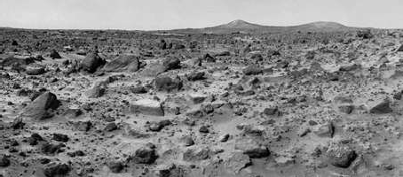

FIG. 4. Rocky surface of Mars at the Pathfinder landing site (NASA photograph)
Spirit and Opportunity landed on opposite sides of Mars (Jet Propulsion Laboratory, 2004). Eagle and Endurance craters studied by Opportunity showed evidence of past inter-dune playa lakes that evaporated to form sulfate-rich sands. After reworking by water and wind, the sands solidified into rock. Layered bedrock in Eagle crater contained embedded BB-size gray spheres that contain hematite. They are also plentiful in the surrounding soil. The Spirit rover discovered finely layered rocks. Still operational more than five years longer than the originally planned mission of three months, Spirit, with five of its six wheels still rotating, recently drove (May 2009) into soft soil. The wheels have been slipping and have now sunk about half way into the ground, as may be seen in Fig. 5 (JPL, 2009).

Martian Soil Mechanical Properties

The mechanical properties of the surface and near-surface soils of Mars have been inferred and deduced from such sources as photographs, interactions of landers and rovers with the surface, remote surface sampling, and measurements of motor currents, temperature and vehicle kinematics during rover movements. Many photographs; e.g., Fig. 4, show gravel, cobble, and boulder-size particles strewn over fairly fine-grained surface layers. Some of the surface contains indurated layers and clods of fine particles. Clearly delineated rover tracks provide evidence of densification under the wheels and some soil cohesion. Representative particle size distribution curves have not yet been obtained. The Pathfinder Mission Rover Team (1997) describes the Martian soil as similar to moderately dense soils on Earth, such as clayey silt with embedded sands, granules, and pebbles. See also Sullivan, et al., (2008) for additional information on the physical properties of Martian soil.
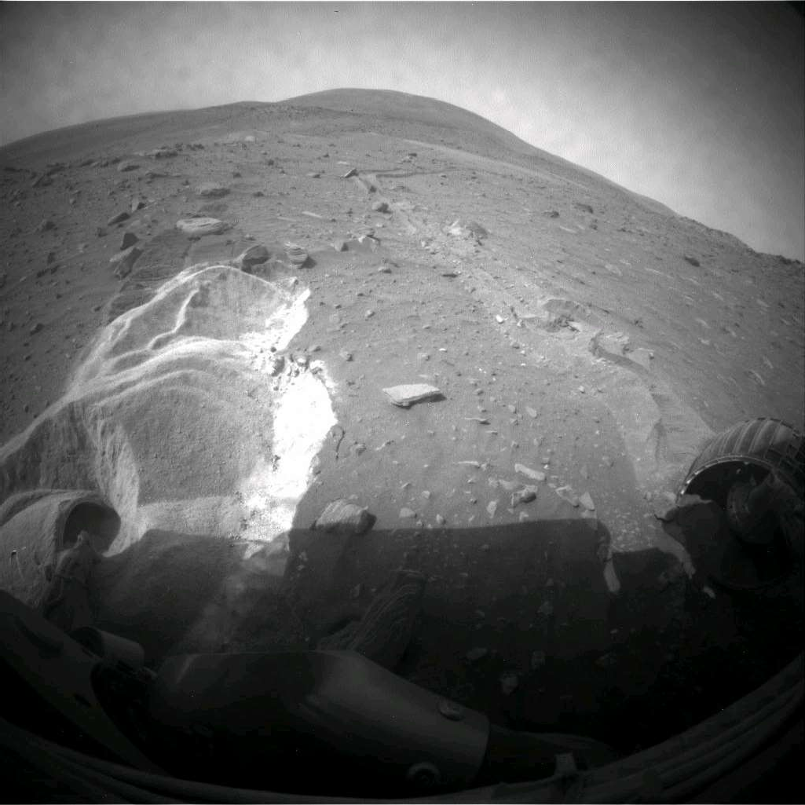

FIG. 5. Wheels of the Spirit rover digging into soft ground on Mars, May 6, 2009 (The right wheel appears to still be developing traction, but the left wheel is axle-deep in the soil and has exposed white soil beneath the surface.)
(Courtesy NASA/JPL-Caltech)

Soil properties deduced from Viking 1 (Shorthill, et al., 1976a) Viking 2 Shorthill, et al., 1976b), and the Sojourner rover (Rover Team, 1997) are summarized in Table
4. Average values of corresponding properties of lunar soil are also shown for comparison.

TABLE 4. Soil Properties Deduced from Viking and Pathfinder Mission Data

Property Viking 1ª Viking 2^{b}
Pathfinder Rover Sojourner^{c}
Lunar Soil^{a,d}

Sandy
Rocky
Bonneville
0 to 0.1
  - to 3

Flats
Flats
and Beta m m

depth depth
Bulk Density | 1-1.6 | 1.8 | 1.5-1.8 | 1.5 | 1.0-1.3 |  | 1.5-2.1
(g/cm³) Particle Size
0.01- | 60 | 30 | 30 |  |  | 30
0.1mm(%)  0.1-2.0mm(%)  Internal friction angle Cohesion | 10  20-40º | 30  40-45º  0.1- | 30  40-45º  1.0 | 32-41º  0.12-0.36 | 42º 0.5 | 30 |  | 46º 0.9
(kPa) |  | 1.0
Coefficient of |  | 0.55- |  | 0.5-0.85 |  | 0.5-1.0
sliding friction |  | 0.65
ª from Shorthill, et al. (1976a); ^{b} from Shorthill, et al. (1976b);^{c} from the Rover Team (1997); ^{d} from Carrier and Mitchell (1989)

SOME GEOTECHNICAL ENGINEERING AND FOUNDATION DESIGN CONSIDERATIONS

Information obtained from unmanned and manned missions to the Moon and unmanned missions to Mars have provided sufficient knowledge of the soil and foundation conditions to support several general conclusions relevant to design and construction of the infrastructure needed to support future space exploration and development. Essential infrastructure needs include shelter, life support systems, mobility, structures and facilities needed for science laboratories and observatories, and ultimately materials processing and manufacturing facilities. Details of current
concepts and planning for these needs is outside the scope of this paper; however,
much information can be found on the NASA web site and related links. Among the significant findings and expectations are the following:

Trafficability and vehicle mobility on the lunar surface are not likely to be major problems. However, there are some very rocky areas that will need to be avoided, and local soft zones were encountered by both the Apollo Lunar Roving Vehicles and Lunokhod that impaired their mobility. Greater difficulties could be encountered on Mars, not only because of the rocky areas (Fig. 4) and soft zones (Fig. 5), but also owing to the more complex geology, greater variety of soil types, and the existence of both water ice and CO₂ ice in the polar regions.

    - Dust problems are likely on both the Moon and Mars. Dust creates both health risks, from inhalation and damage to spacesuits, and mission risks, from obscuring landing sites, equipment overheating, and covering solar arrays (National Research Council, 2008). NASAs current Lunar Dust Mitigation project is focused on addressing these problems.
    - The silty fine sand soil and its high density reached at shallow depth on the Moon indicate that it will be capable of supporting high foundation loads on shallow foundations. As the depth to high density soil layers on Mars is not yet reliably known, further information is required before an assessment of its ability to support large and heavy loads on shallow foundations can be made. Bearing capacity is likely to be more site-specific on Mars than on the Moon.
    - Thin-walled core tubes cannot be driven manually deeper than about 0.7 m on the Moon. Power drilling to significantly greater depths is possible.
    - Core tube and drill holes on the Moon remain open. Therefore, it should be possible to excavate with stable vertical walls to a depth of 2 m or more. Qualitatively similar behavior can be expected on Mars; however, the stronger gravitational field on Mars will limit the depth for a given value of soil cohesion.
    - Owing to the high density of lunar soil at depths greater than a few cm, excavated soil will exhibit bulking when recompacted. The present in-situ properties of lunar soil at high relative density are likely to represent an upper bound for strength and lower bound for compressibility after excavation and recompaction.

IN-SITU RESOURCE UTILIZATION

The objective of In Situ Resource Utilization (ISRU) is to extract elements and minerals from the land and/or atmospheric materials that are present on the Moon and Mars (National Research Council, 2008). At a cost of about $100,000 per kg to transport materials to the Moon, considerable savings would be possible if local materials could be used. NASAs near-term goal is to produce oxygen from the lunar regolith for life support at 1 ton per year. Its mid-range goal is 10 tons per year to refuel propellant tanks, and over the long range, to extract metals for parts fabrication. Concurrently, a number of studies are being made to enable utilization of lunar soils and rock as construction materials. None of these goals are likely to be achievable without consideration of important geotechnical issues; e.g., drilling, sampling and testing of soils and rocks, dust control, excavation, vehicle mobility and trafficability, tunneling, and foundation engineering.

CONCLUSIONS

Reliable knowledge of the soils and their properties will be an essential part of successful further manned exploration and development on the Moon and Mars. All activities on these bodies will be on, in, and/or with the soils and rocks that are there. Knowledge of soil conditions on the Moon is relatively good. On the average, the soil is a silty fine sand composed of grains of several known types formed by

meteoroid impact, increasing to a relative density of 90 percent or more at a depth of 30 cm. Strength and compressibility properties depend primarily on relative density. Although the density is somewhat less on slopes and crater rims, the soil conditions are much the same everywhere on the Moon.
On the other hand, the conditions on Mars are much more variable and complex owing to the presence of a gaseous atmosphere, albeit one that is very thin in comparison with the Earth, and a history that has involved hydro, volcanic and aeolian processes. Mars is intermediate relative to the Earth and the Moon in terms of the variability and complexity of surficial geologic conditions. The finer grained surficial soils appear somewhat similar to the silty fine sands that cover the Moon, however, some areas are populated with gravel, cobble, and boulder-size rocks. Sand dunes are found in some areas, and playa lake bed type deposits have been found in others. Dust is ubiquitous on both the Moon and Mars, and it adversely impacts both equipment and astronaut activities.
The surfaces of both the Moon and Mars appear capable of supporting vehicles and structures of the types presently envisioned for the next generation of exploration and development, although soft zones on Mars may require special care. Were it not for the unique and harsh environmental conditions, in addition to the great distances and their impacts on material transport and communications, engineering and construction on, in, and with the silty fine sandy soils of the Moon and Mars would be straightforward.

REFERENCES

Banin, A. (2005). The enigma of the Martian soil, Science, Vol. 309, no. 5736, pp. 888-890.
Carrier, W. D. III (1973). Lunar soil grain size distribution, The Moon, Vol. 6, pp. 250-263.
Carrier, W.D. III (2003). Particle size distribution of lunar soil, Journ. Soil Mech. and Found. Div., ASCE, Vol. 129, pp.956-959.
Carrier, W.D.III, Mitchell, J.K. and Mahmood, A. (1973). The nature of lunar soil, Journ. Soil Mech. and Found. Div., ASCE, Vol. 99, pp.813-832.
Carrier, W.D. III, Oelhoeft, G.R., and Mendell, W. (1991). Physical properties of the lunar surface, Chapter 9 in Lunar Source book, Cambridge University Press, Cambridge, pp.475-594.
Carrier, W.D. III and Mitchell, J.K. (1989). Geotechnical Engineering on the Moon, in De Mello Volume, Editora Edgard Blücher Ltda., So Paulo, Brasil, pp.51-58.
Heiken, G.H., Vaniman, D.T., and French, B.M. (eds) (1991). Lunar Sourcebook, Cambridge University Press, 736 pp.
Houston, W.N., Mitchell, J.K., and Carrier, W.D.III (1974). Lunar soil density and porosity, Proc. Fifth Lunar Science Conf., Pergamon Press, New York, pp.2361-2364.
Jet Propulsion Laboratory (1988), Viking Mission to Mars, NASA Facts, 8 pp. Jet Propulsion Laboratory (1999), Mars Pathfinder, NASA Facts, 8 pp.
Jet Propulsion Laboratory (2004), Mars Exploration Rover, NASA Facts, 8 pp.

Jet Propulsion Laboratory (2009). Soft ground puts Spirit in danger despite gain in daily energy, http://marsrovers.jpl.nasa.gov/newsroom/pressreleases/20090511a.html.
Mitchell, J.K., Houston, W.N., Carrier, W.D. III, and Costes, N.C. (1974). Apollo Soil Mechanics Experiment, S-200, Final Report, NASA Contract NAS 9-1126, Space Sciences Laboratory Series 15, Issue 7, University of California, Berkeley.
National Research Council (2008). A Constrained Space Technology Exploration Program, National Academies Press, Washington, DC, 154 pp.
Rover Team (1997). Characterization of the Martian surface deposits by the Mars Pathfinder Rover, Sojourner, Science, vol. 278, no. 5344, pp. 1765-1768.
Schmitt, H.H. (2009). Space geology: from the Moon to Mars, Scientific American, July 2009
Shorthill, R.W., Moore, H.J., II, Scott, R.F., Hutton, R.E., Liebes, S., Jr., and Spitzer,
C.R. (1976a). The soil of Mars (Viking 1), Science, vol.194, no. 4260, pp. 91-97. Shorthill, R.W., Moore, H.J., II, Hutton, R.E., .Scott, R.F., and Spitzer, C.R. (1976b).
The environs of Viking 2 lander, Science, vol.194, no. 4271, pp. 1309-1318. Sullivan, R., R. Arvidson, J. F. Bell, R. Gellert, M. Golombek, R. Greeley, K.
Herkenhoff, J. Johnson, S. Thompson, P. Whelley, and J. Wray, 2008, Wind-driven particle mobility on Mars: Insights from Mars Exploration Rover observations at
El Dorado and surroundings at Gusev Crater, J. Geophys. Res., 113, E06S07, doi: 10.1029/2008JE003101.
Taylor, G.J., Warren, P., Ryder, G., Delano, J., Pieters, C., and Lofgren, G. (1991).
Lunar rocks, Chapter 6 in Lunar Source Book, Cambridge University Press, Cambridge, pp. 183-284.

